**LAB – 1 :- Python : User – intersection is must**

**Q.1.** Write a program for arithmetic operators

Ans :

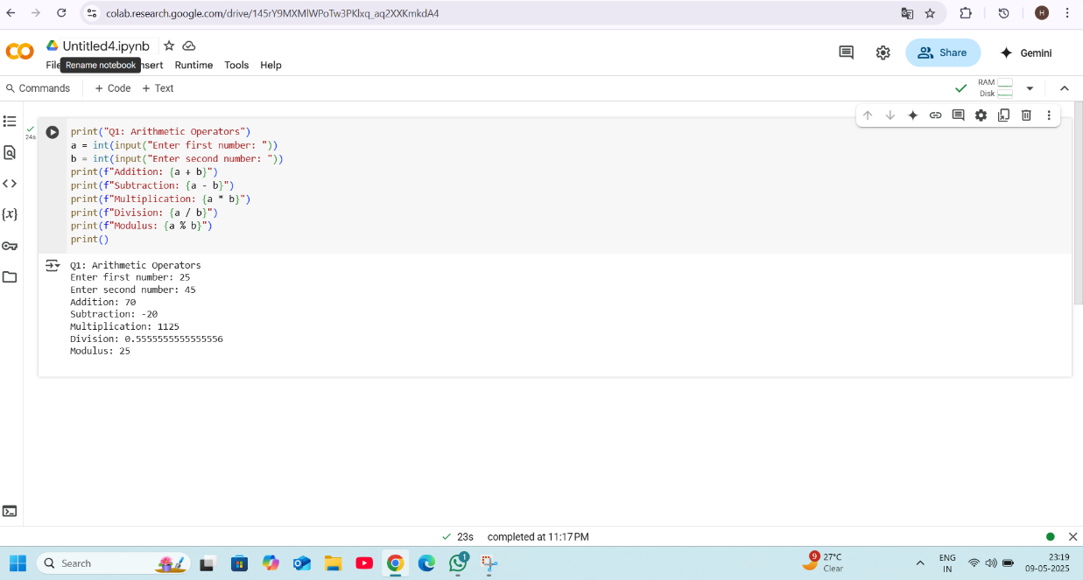

**Q.2.** Write a program for assignment operators

Ans:

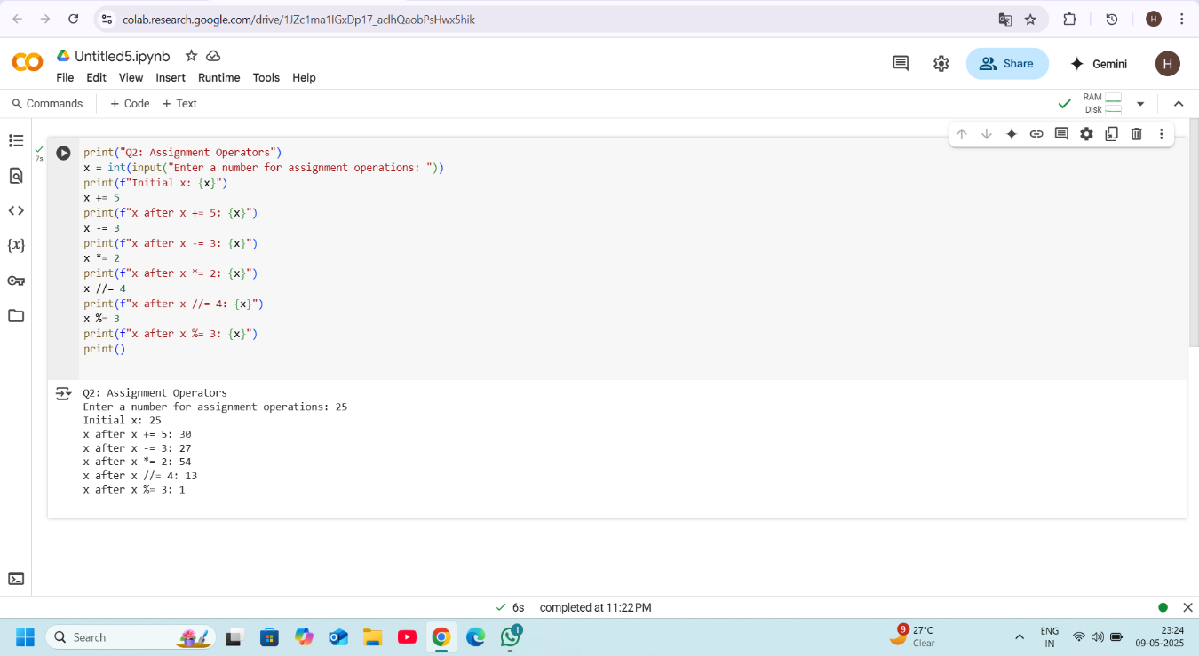

Q.3. Write a program for Bitwise operators.

Ans:

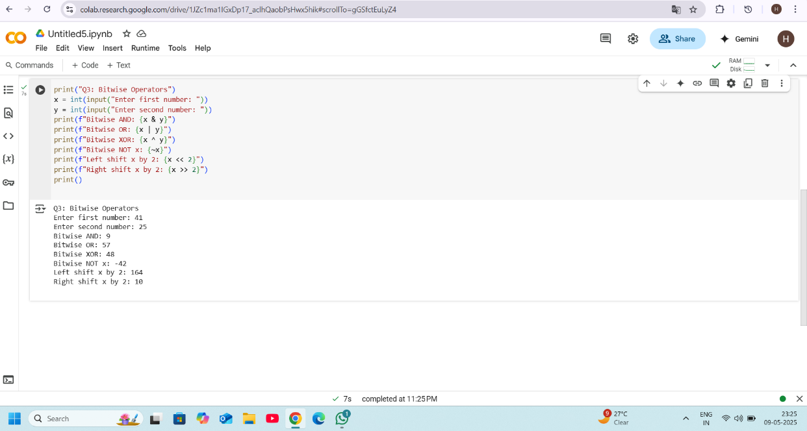

Q.4. Write a program to calculate greatest of three numbers.

Ans:

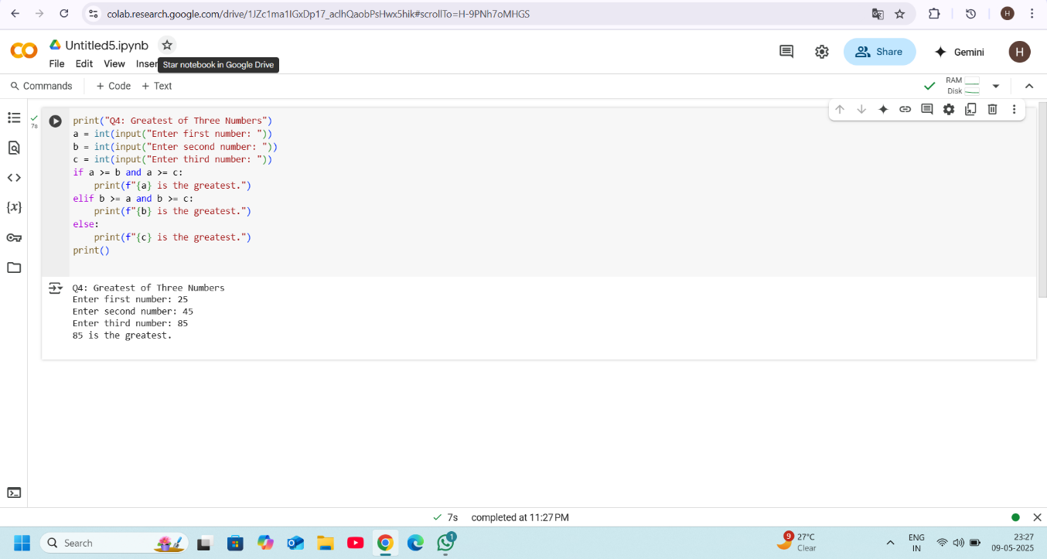

Q.5. Calculate the area of circle.

Ans:

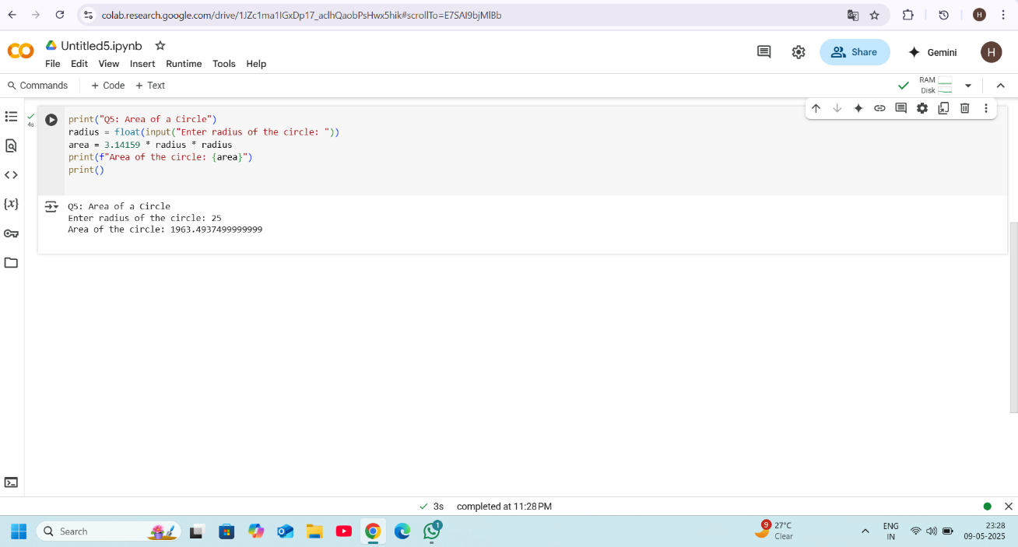

Q.6. Calculate the area of a triangle.

Ans:

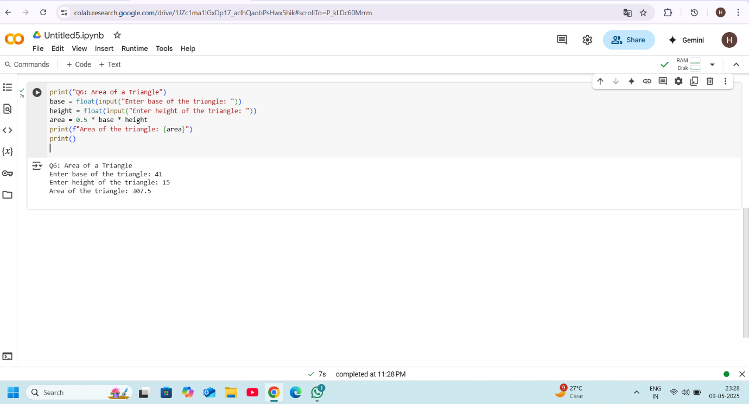

Q.7. Calculate the area of a rectangle.

Ans:

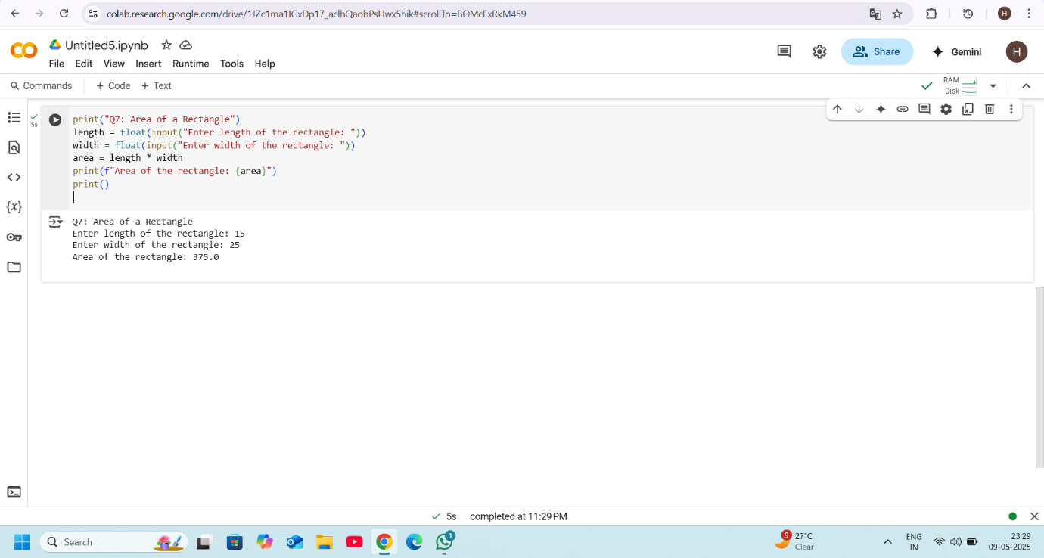

Q.8. Calculate the area of a Square.

Ans:

